Bid Inviter
  - Listing Form
Basic Details
Every Pages/Section of the form should show the registration details of the bid inviter that may include:
- Company Name/ Registration Id
- PAN/VAT NO
- Contact Details
- Any Other Details
Reference Image
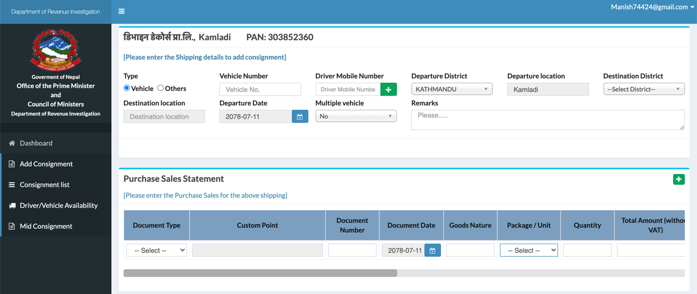

Page/Section 1 (Product Specification)
This section/Page is for adding all the necessary details required by the bid invited for the product/service they are listing the bid for. This will include following tab
S.No | Product Name | Brand Name | Item No | S.I  Units | Product Description | Remarks

This would be the basic form, and upload option will be required here to add specification of complex products where more detailing can be required, which we will get from the bid inviter directly.

Page/Section 2 (Purchase Criteria)
This form will continue the indirect product related specification such as
- Test Certificates
- ISO Certifications
- Delivery Location
- Date of Execution
- Date and Time of Bidding
- General terms and conditions related to product.
- Payments Terms
- Insurance terms
Also add custom fields for adding more information as required.

Page/Section 3 (PRice Schedule)
We name this section as purchase statement a table must be drawn here to fill in the rates of the product required by the invited:
A | FURNITURE | Unit | Qty | Rate | Amount | Remarks
1 | Office | Nos | 1 | 30,500.00 | 30,500.00 | CEO Table
2 | Side Table | No | 1 | 10,500.00 | 10,500.00 | CEO table

A + icon should be built in the right-hand side table to keep adding the products. Multiple section option should also be included for multiple product category listing. A subtotal and a grand total mechanism should be built for suppliers who are quoting rates for.
Reference:
No | Item with requested specifications | Unit | Quantity | Unit Price  NPR | Amount
A. | Vertical Blinds for Embassy Office Ground Floor (Reception)
 | Vertical Blinds | 1 Sq Ft. | 52.5 | 90.00 | 4725.00
 | Fitting Charge | 1 Pec | 2 | 200.00 | 400.00
 |  |  |  |  | 5125.00
B. | Vertical Blinds for Embassy Office Ground Floor (Sitting Room)
1. | Vertical Blinds | 1 Sq Ft. | 125 | 90.00 | 11250.00
2. | Fitting Charge | 1 Pec | 3 | 200.00 | 600.00
 |  |  |  |  | 11850.00
C. | Vertical Blinds for Embassy Office Ground Floor (Kitchen)
1. | Vertical Blinds | 1 Sq Ft. | 34 | 90.00 | 3060.00
2. | Fitting Charge | 1 Pec | 1 | 200.00 | 200.00
 |  |  |  |  | 3260.00
D. | Vertical Blinds for Embassy Office Ground Floor (Toilet)
1. | Vertical Blinds | 1 Sq Ft. | 11 | 90.00 | 990.00
2. | Fitting Charge | 1 Pec | 1 | 200.00 | 200.00
 |  |  |  |  | 1190.00
E. | Vertical Blinds for Embassy Office Ground Floor (Server Store)
1. | Vertical Blinds | 1 Sq Ft. | 60 | 90.00 | 5400.00
2. | Fitting Charge | 1 Pec | 2 | 200.00 | 400.00
 |  |  |  |  | 5800.00
F. | Vertical Blinds for Embassy Office Ground Floor (Meeting Room)
1. | Vertical Blinds | 1 Sq Ft. | 86 | 90.00 | 7740.00
2. | Fitting Charge | 1 Pec | 5 | 200.00 | 1000.00
 |  |  |  |  | 8740.00
 | Total Amount A+B+C+D+E+F |  |  |  | 35965
 | Vat 13% |  |  |  | 4675.45
G.F | Grand Total |  |  |  | 40640.45

Page/Section 4 (Eligibility Criteria)
This is the section where bid invited can customize his requirement to work with some certain qualified suppliers where Filters for following fileds should be created:
- Annual Turnover
- Stock/ Inventory Availability
- Tax Clarence
- Past Performance/ Experience
- Human and Technical Manpower
- And Custom field for adding more requirements

This is the basic framework we will keep updating things to make the form more robust and user friendly.

